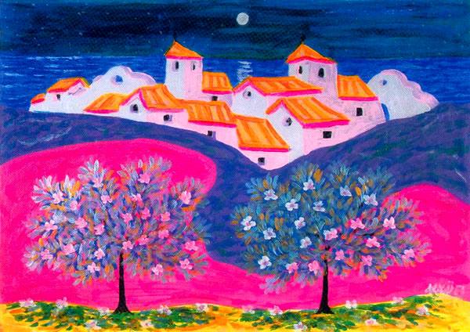
Ilusión óptica en el mar

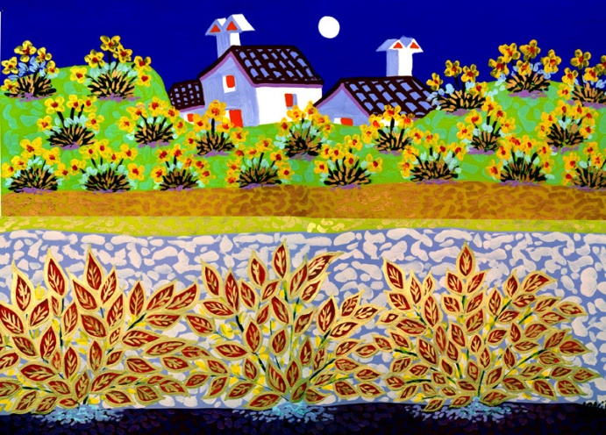
Cortijo el Chaparral

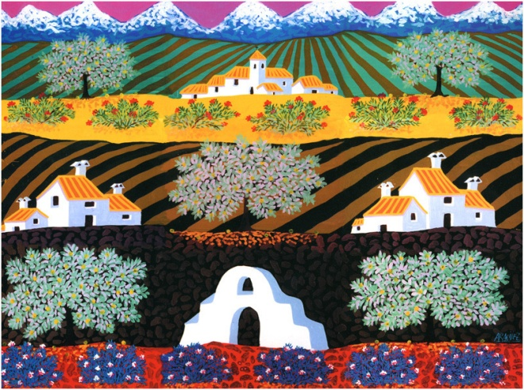
Caminos de la ilusión
Técnica mixta, 210x150 cm

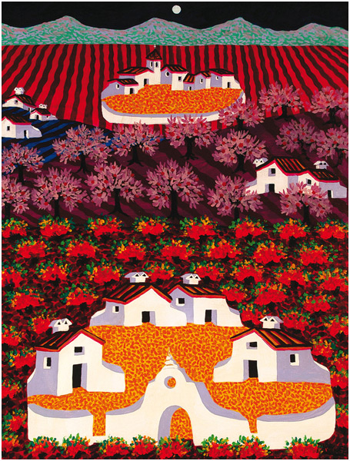
Cortijos al atardecer
Técnica mixta, 116x89 cm., 1993

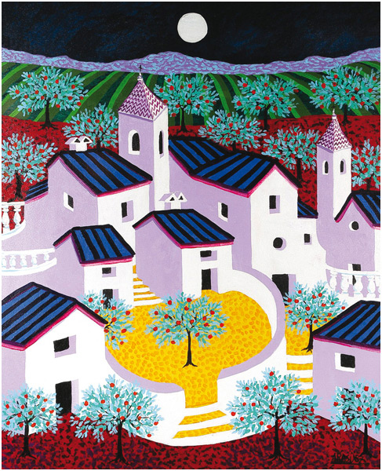
Cortijada
Técnica mixta, 100x81 cm., 1991
Santiago Fernandez-Aragüez was born and lives in Vélez-Málaga , southern Spain, in a region called the Axarquía, well known due to its microclimate and light. He is secondary school teacher and many of his murals can be found in schools in all the surrounding villages. He has won numerous awards and exhibited all over Spain. His paintings are known for the omnipresent Mediterranean Sea, the effects of light and his distinctive use of color. More of his work can be found on his webpage: http://www.araguez.com/inicio.html

